Improved bonding method of release film for ultrasonic assisted 3D printing process
Z Y Wang1,2, B Cui1,2,3, T F Zheng1,2
1 School of Mechanical Engineering, Xi’an Jiaotong University, Xi’an 710049, China
2 State Key Laboratory for Manufacturing and Systems Engineering, Xi’an 710049, China

Corresponding author e-mail: cuibin@xjtu.edu.cn
Abstract. In aerospace, automobile manufacturing and other fields, carbon fiber reinforced composite materials are widely used to obtain light weight and high strength characteristics. We mixed the carbon fiber into the light-curable resin, tried to use some acoustic methods to improve the distribution of the carbon fiber, and finally used the UV light source to cure the required workpiece. Under the printing process of selective area curing, controllable appearance and shape of the workpiece can be obtained. Although the release film has been used in the above process, the separation of the cured resin from the quartz resin container has always troubled us. By changing the bonding method of the release film, we compared the separation effects of 3 different methods, and finally obtained a relatively good effective separation method, and will continue to apply it to the next experiment.
- Introduction
Carbon fiber reinforced composite materials have excellent fracture mechanical properties on the basis of light weight, so they are widely used in the production of automobiles and airplanes. At present, in the 3D printing process, the trend of producing carbon fiber reinforced composite materials by using resins added with reinforcing materials such as carbon fiber, glass fiber, and Kafra fiber is becoming more and more widespread. In our current work, we are not only limited to manufacturing this composite material mixed with fibers, but also hope that it has a controllable ply orientation angle similar to traditional long fiber/short fiber composite materials. Ultrasound-assisted stereolithography is a novel way to obtain samples with a single-layer particle arrangement pattern. Ultrasound-assisted stereolithography is a novel method to obtain samples with a single-layer particle arrangement pattern. It usually arranges particles, short fibers and cells in a quartz square trough. During our exploration, we encountered two more difficult troubles: the transmittance of the resin during the curing process and the separation of the resin from the quartz cube after curing. We can solve the problem of enhancing light transmission by reducing the thickness of the single layer, but the latter trouble has not been solved for a long time.
Its principle is to install a device that can generate an ultrasonic standing wave field on the printing platform. The standing wave field can confine various particles at the node (usually, but not all particle types). In the surface forming light curing printing equipment, the release film plays an important role in the forming process. Figure 1 shows the basic steps of surface forming light-curing printing. First, press the printing platform to the bottom end in a container containing photosensitive resin and raise it to a certain height (the thickness of a single layer). The light curing device composed of the LCD screen at the bottom of the container and the ultraviolet light source cures the single-layer pattern; here the LCD screen acts as a mask, and the ultraviolet light can only pass through the white pattern part and be absorbed in other parts . Next, the printing platform is raised to the thickness of a single layer again, and the release film will start to work. Under the action of the release film, the cured resin parts will more easily adhere to the printing platform above instead of the container. bottom of. The light curing device performs the curing of the second layer pattern again; repeat the above step until the processing of the entire part is completed.
When the ultrasonic device is combined with the surface forming printing device, a quartz container is used to contain the photosensitive resin doped with particles. Quartz containers can better transmit and reflect sound waves, which is advantageous for ultrasonically assisting to complete the single-layer particle arrangement pattern, but this type of container is different from the resin-containing container in commercial printing equipment. In order to meet the needs of the test experiment, we decided to design a temporary but reliable release film fixing method in the laboratory environment to achieve the purpose of rapid release.
- Scheme and test
Quartz glass has better sound wave propagation and reflection effects than polymer materials. Therefore, we have customized a batch of quartz containers with an internal size of 64×64×10mm, and its wall thickness is 2mm. Here we propose three feasible solutions to solve the release problem in the ultrasound-assisted stereolithography process.
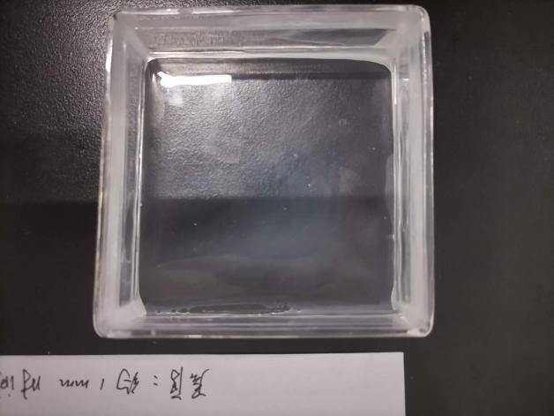
Figure 1. Platform and square quartz container used.

Method of sticking directly with adhesive
The first method we tried was to directly stick the release film to the bottom of the quartz container with an adhesive, which is the most direct way imaginable. The adhesive selected in this way needs to have good transparency and allow unimpeded penetration of ultraviolet light. It needs to be able to firmly bind the release film to the bottom of the quartz container while being waterproof. We chose a light-curable glue that meets the conditions as the adhesive, and the heat generated during curing can also help it obtain better adhesion.

Cover with a thin PDMS layer
Release film is not the only option. Polydimethylsilane (PDMS) coating is also used for release in the resin container of many commercial printers. First put the cleaned quartz container on the drying table to dry the moisture. Vacuum the pre-mixed PDMS (Dow Corning, 10:1 mixing) until it is clear, and pour the calculated volume into a quartz container. Vacuum the quartz container onto the homogenizer, spin-coating at 2000 rpm for 10 minutes, take it off and check whether it meets the requirements. Put the quartz container in a vacuum drying oven and dry it at 85°C for 4 hours to ensure that the surface is dry.

Use mechanical tension
This scheme imitates the release film fixing method of commercial printers, using mechanical tension. In comparison, our approach is a simplified version. First, the release film is cut into the shape described in Scheme 2.1, and is lined on the inner wall of the quartz container. Next, we use two glass plates to directly press the release film to ensure that the release film can be myopic fit on the bottom surface, and then use light-curable glue to firmly seal the four corners of the quartz container.
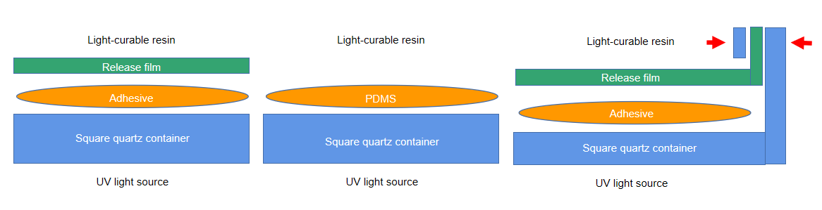
Figure 2. Simple schematic diagram of 3 ways.
- Discussion
We use a photosensitive resin doped with short carbon fibers for testing experiments, and directly use the adhesive method to obtain a good release effect. The obtained sample has a flat surface and can complete the release work many times in a row. However, due to the limited water resistance of the light-curable glue used, gaps will begin to form between the light-curable glue and the quartz container after tens of continuous release layers are used, and continued use will eventually cause the release film to fall off. Once the release film falls off, it is necessary to completely clean the inside of the entire quartz container and then re-bond it, which may spend a lot of time.
The method of using a thin PDMS layer to replace the release film needs to ensure that the PDMS thin layer is completely dry, so that a better release effect can be obtained. However, even if the coating is thin enough, the arrangement of the particles by the sound wave will be affected, and the ideal particle pattern cannot be obtained. This is mainly because PDMS is a material that absorbs more ultrasound, and the number of times PDMS is used as a release film is limited. After using for a long time, PDMS will start to turn white, which will affect the light transmittance and lead to poor molding quality.
The mechanical tension force to fix the release film can obtain a flat sample surface. The molding effect is the same as the direct adhesive bonding method. The same problem exists: the light-curing glue will gradually desorb from the surface of the quartz glass over time Peel it off. Therefore, after the curing of dozens of layers, if there is a gap that needs to be repaired, it will take a few minutes. Compared with the direct bonding method, it saves a lot of glue and repair time, and can get more Good light transmittance. By comparing these three solutions, we finally selected a mechanical clamping method that is more convenient to handle, which can ensure good light transmittance and is more convenient to repair. Later, we will continue to try other optional processing methods to improve our devices, such as silanization of the inner surface of a quartz container or the use of a commercial printer's resin container.
References
- A referenceJones R M. Mechanics of Composites Materials. 2nd ed. USA Philadelphia: Taylor & Francis, Inc. ,1998.
- Bunsell A R, Renard J. Fundamentals of fibre reinforced composite materials. Institute of Physics, 2005.
- MS Scholz, BW Drinkwater, et al.. Ultrasonic assembly of anisotropic short fibre reinforced composites[J]. Ultrasonics, 2014.
- Yunhai M, Qian W, Lingjian D, Siyang W, Qingping L, Bingqian L and Xueli Zhou 2020 J. Journal of Materials Science. 55 15510
- Apichattrabrut T, Ravi-Chandar K. Helicoidal composites [J]. Mech. Adv. Mater. Struct., 2006.
- Llewellyn-Jones T M , Drinkwater B W , Trask R S . 3D printed components with ultrasonically arranged microscale structure[J]. Smart Material Structures, 2016.

